**ISYS6256 – INFORMATION SYSTEM PROJECT MANAGEMENT**

**Andri Irwandi - 2201743131 – LO11**

1. The major problems associated with this project is

Customer support of the product.

As a customer, if I have an trouble on Jawbone’s sytem or the product, I will search on their forum and tell them what problem that I have.

Jawbone’s create their own website and their social media’s. As we know, website is very important to show Jawbone’s customer about what is Jawbone’s, why customer must buy Jawbone’s. But, jawbone’s didn’t support their website forum, so why they create their own website if Jawbone’s team didn’t support their website.

Jawbone’s create their social media. Social media is very important, for promotions, customer services and many more. But Jawbone’s team untouched their social media for months. There are no promotion on social media for a month, customer that asked something on Jawbone will be ignored. Customer will feels that they didn’t care about their customer.

The other problem, when the company take over the other company, the one who takes over didn’t care about the customer who being bought by them like fitbit. Customer feels like after the company bought pebble their will be no software update that meaning full and fitbit didn’t care about it.

1. Lesson that we can learn from Jawbone’s failure

How to maintain their customer support, if the company didn’t treat them well their will be the sam feedback thath come to the company.

Jawbone’s create their own website and their social media’s. As we know, website is very important to show Jawbone’s customer about what is Jawbone’s, why customer must buy Jawbone’s. But, jawbone’s didn’t support their website forum, so why they create their own website if Jawbone’s team didn’t support their website. So, an active website and interesting website will attrack the customer.

Jawbone’s create their social media. Social media is very important, for promotions, customer services and many more. But Jawbone’s team untouched their social media for months. There are no promotion on social media for a month, customer that asked something on Jawbone will be ignored. They must active on Social media, because in this era, all people busy on their own smartphone and social media’s. Jawbone’s can promote their self like on Instagram story and many more.

1. **A.PLC AND SDLC**

* PLC

1. Project Initiation

* On the beginning, make a project charter that describe the project.
* Project purpose, vision and mission
* Elaborated project description, condinition and risk
* Concerned stakeholders

(Describe the project that be maked = jawbone)

1. Definition and Planning

- Making scope and budget

- Making gantt chart

- Making WBS (Work Breakdown Schedule)

- Risk management

(The plan of making jawbone like the budget estimation, the time and schedule of makin Jawbone)

(Improve customer relation management system)

1. Launch

-Launch project management plans

-List the procurement

-Manage the procurement

-Make the meeting schedule

(Execute the plan project with SLDC method)

(What procurement that needed to make a jawbone)

1. Performance and Control

-Control that everything on the project is run well with the project management plan

(Control the making of Jawbone’s, like each step of the production, to get a good quality of Jawbone)

1. Project Close

-Make the punchlist

-Show the final project budget

-Make the report

(Make the final report about the Jawbone project like all cost on making Jawbone and all the report from start – end)

(Make the final presentation of Jawbone’s)

* SDLC

1. Requirement Analysis

-Identify the current problem

Getting input from all stakeholders (Customers ,sales,programmers, etc)

-What are the current problem

-Learn the strength and weakness of the current system with improvement as the goal

(Why i must creating a Jawbone by identify the problem. In this era, all modern thats why Jawbone was made)

1. Planning

-What do I want

-Determine the cost and resources required for implementing the analyzed requirement

-Analyze the customer problem

-Analyze the requirement

-Details the risk involved and provides sub-plans for softening the risk.

(What do i want about the Jawbone, like what the excess of Jawbones)

1. Architectural Design

-How will I get what I want

-Turning the software specifications into a design plan

-Review the plan and offer feedback and suggestions.

-Create the physical and logical of CRM system.

(The design of Jawbone that will make. Design is important, people will attract of our Jawbone if the design is elegant and cool)

1. Software Development

-Create what I want

-Make sure I have a proper guidelines

(Start the production of Jawbones periodically for the customer)

5. Testing

-Did I get what I want

-Test for defects and deficiencies.

-Fix the isssues until the product meets the original specification.

(Test our Jawbone, that the Jawbone are in accordance with the project expectation or not)

6. Deployment

-Start using what I got

-Deploy the software to the production environment so users can start using the product.

-Allows any stakeholder to safely play with the product before releasing it to the market.

-Allows any final mistakes to be caught before releasing the product.

(Share our Jawbone to people who are allowed for the tester, and if there any mistake of our Jawbone, fix it)

**B. MOV**

|  |  |  |  |  |
| --- | --- | --- | --- | --- |
| Customer | Strategic | Financial | Operational | Social |
| -Give a better quality product and services.  -Give a lower prices of Jawbone’s.  -Give a better customer support. | -Increased new market, like on Asia and many more.  -By giving a promo like buy 2 jawbone’s got discount 20%.  -Active on social media to interact the customer and giving promotions there  -Endorsment with famous people like youtuber and others. | -Sales growth of our Jawbone’s up to 40% by the end of next month and so on.  -Reduce unnecessary expenses. | -Implement the ERP system  -More efficient processes  -More effective processes | -The number of accident in our plant is reduced to zero next month. |

**C.DEVELOP BEP AND NPV**

-BEP(Break Even Point)

Initial Investment

|  |  |
| --- | --- |
| Machine Cost | $40000 |
| Material Cost | $10000 |
| Employee Cost | $12000 |
| Operational Cost | $8000 |
| **INITIAL INVESTMENT** | **$70000** |

Net Profit Margin

Cost/unit : $70

Sales : $180

NPM = $110

BEP = Initial Investment : Net profit margin

= $70000 : $110

= 636 unit

-NPV (Net Present Value)

Cash In flows

|  |  |
| --- | --- |
| Gross receipt in cash | $45000 |
| Cash received from debtors | $15000 |
| **Total cash inflows** | **$60000** |

Cash out flow

|  |  |
| --- | --- |
| Interest paid | $8000 |
| Salaries paid in cash | $19000 |
| Rent paid | $20000 |
| Cash paid to supplier | $23000 |
| **Total cash outflows** | **$70000** |

|  |  |  |  |  |  |
| --- | --- | --- | --- | --- | --- |
|  | Year 0 | Year 1 | Year 2 | Year 3 | Year 4 |
| Total cash in flows | 0 | 60.000 | 75.000 | 120.000 | 170.000 |
| Total cash out flows | 70.000 | 25.000 | 30.000 | 50.000 | 80.000 |
| Net cash flows | (70.000) | 35.000 | 45.000 | 70.000 | 90.000 |

Discount rate = 8%

|  |  |  |
| --- | --- | --- |
| Time Period | Calculation | Discounted cash flow |
| Year 0 | (70.000) | (70.000) |
| Year 1 | 35.000/(1+0.08)1 | 32.407 |
| Year 2 | 45.000/(1+0.08)2 | 38.580 |
| Year 3 | 70.000/(1+0.08)3 | 55.568 |
| Year 4 | 90.000/(1+0.08)4 | 66.152 |
| Net Present Value | | **$122.707** |

**D.WBS (Work Breakdown Structure)**

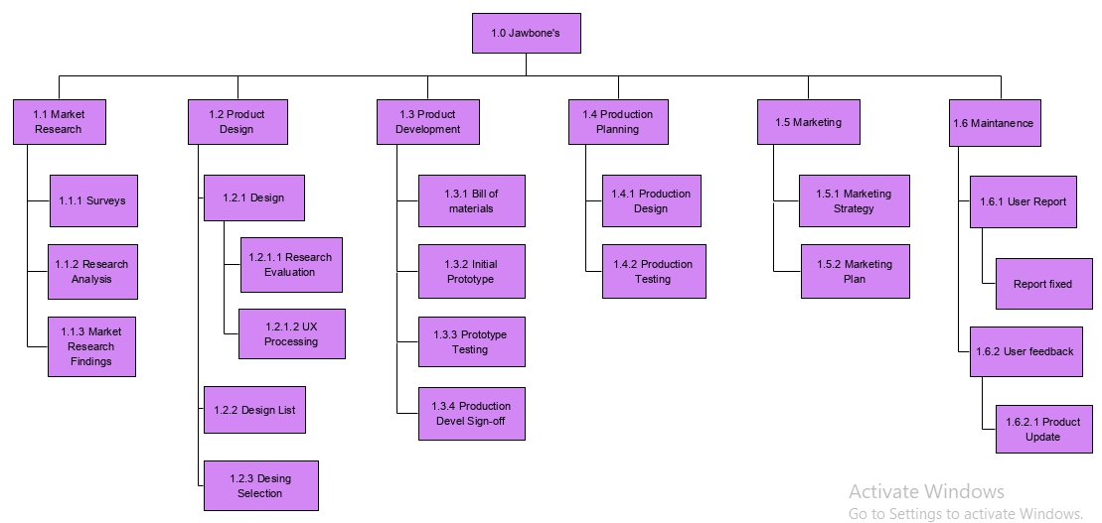

PS : I make WBS with Visual Paradigm

**E. Project Infrastructure**

|  |  |
| --- | --- |
| Task of the Project | Person in Charge |
| Evaluate current technology platform | Project Manager |
| Define user requirements | Software Engineer |
| Design the prototype | Designer Manager |
| Set up the prototype | Designer Analysis |
| Estimate the product traffic | Market Research Analysist |
| Test the product function | Quality Control |
| Move the product to the production environment | Staff |
| Make the announcement of the product procceses | Maintanence Manager |
| Train users | Marketing |
| Write report to the management | Cost Product control |

-Analogy of Project Infrastructure

|  |  |
| --- | --- |
| **Area** | **Rationale** |
| Business Processes | Find the most efficient processes of the project making or a Jawbone making, as much as possible eliminate the duplication data to make a good Jawbone’s. |
| Automation | Identificate if there are a possible of automation, by creating a Jawbone |
| Measurement | Measure what track that which allows, what things that can happen to our product - Jawbone |
| Organisational Structure | Determine who is responsible on the structure like for example project manager responsible on project planning of Jawbones |
| Communication | Communicate each other among one department with another department to produce a good quality of Jawbone’s |

-Role of project Infrastructure

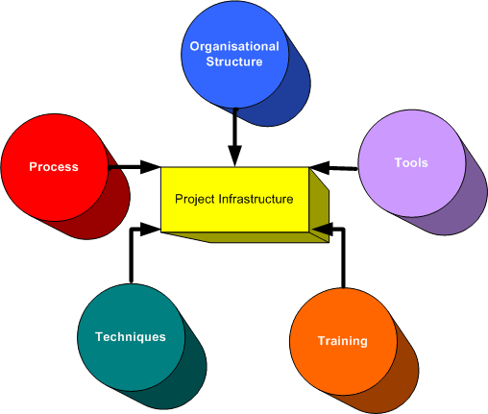

Explanation of the role :

-Organisational Structure

This structure include a project management office, project recruiting function and financial.

-Processes

All the process from start until the end of the process of the production of Jawbone’s.

-Tools

The tools of making a production of a Jawbone’s. Like the materials of making a Jawbone’s.

-Techniques

Repeatable processes

-Training

Formal and informal training for the staff of making Jawbone and give a training also for the users.

**F. Project Budget and Scheduling**

Project Scheduling

-Gantt Chart

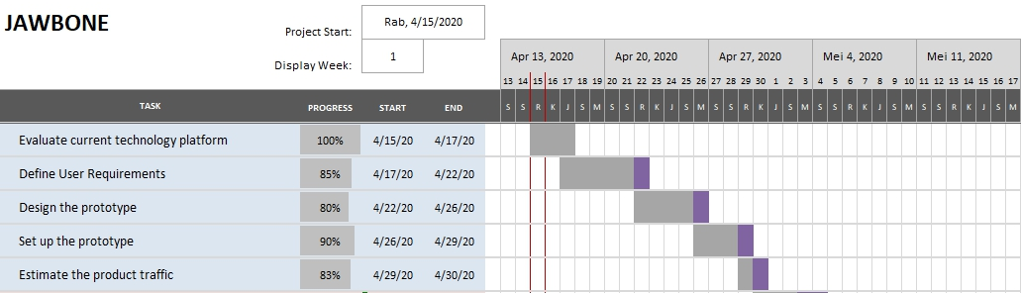

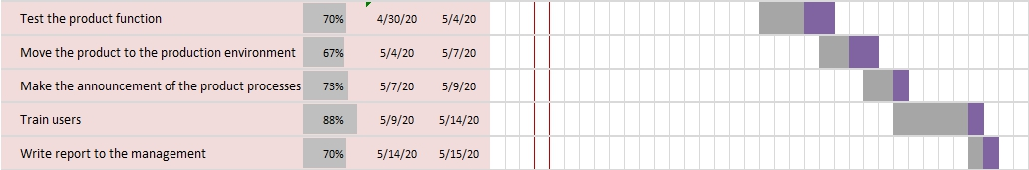

-Activity of Analysis

|  |  |  |  |
| --- | --- | --- | --- |
| Activity | Description | Estimated (Days) | Predecessor |
| A | Evaluate current technology platform | 2 | - |
| B | Define user requirements | 5 | A |
| C | Design the prototype | 4 | B |
| D | Set up the prototype | 3 | B |
| E | Estimate the product traffic | 1 | B |
| F | Test the product function | 4 | C,D |
| G | Move the product to the production environment | 3 | D,E |
| H | Make the announcement of the product procceses | 2 | F,G |
| I | Train users | 5 | G |
| J | Write report to the management | 1 | H,I |

-AON network diagram

F

C

H

J

D

A

B

I

G

E

Project Budget

|  |  |  |
| --- | --- | --- |
| Task | 15 – 30 April 2020 | Mei 1- 14 2020 |
| (1) Evaluate current technology platform | $2300 |  |
| (2) Define user requirements | $1800 |  |
| (3) Design the prototype | $5300 |  |
| (4) Set up the prototype | $3000 |  |
| (5) Estimate the product traffic | $2200 |  |
| (6) Test the product function |  | $2000 |
| (7) Move the product to the production environment |  | $900 |
| (8) Make the announcement of the product procceses |  | $500 |
| (9) Train users |  | $660 |
| (10) Write report to the management |  | $1000 |
|  | $14.600 | $5060 |
| TOTAL | | **$19.660** |

Link Youtube unlisted : <https://youtu.be/CEj5ssI9_S8>

template gantt chart(<https://www.teamgantt.com/free-gantt-chart-excel-template>)

PLC (<https://www.invensislearning.com/resources/pmp/what-is-project-life-cycle-and-its-main-characteristics>)

SDLC (<https://www.tutorialspoint.com/sdlc/sdlc_overview.htm>)

WBS references (<https://www.bing.com/images/search?view=detailV2&id=C94F83B6E8CCBCCFB95CCC0993AB4B5ECB70447A&thid=OIP.dssK-A63tYb9yyX1IYByaAHaFf&exph=430&expw=580&q=work+breakdown+structure&selectedindex=8&ajaxhist=0&vt=0&eim=0,1,2,3,4,6,8,10>)

Project Infrastructure references

(<http://www.projectperfect.com.au/info_project_infrastructure.php>)

Aon – BinusMaya

(Formal and informal training and reference documentation-Resources-ISPM)